What are Propositions? ... from a Concept Mapping Perspective
Alberto J. Cañas
Institute for Human and Machine Cognition
www.ihmc.us

This document is part of the Cmappers.Learn section of www.cmappers.net. Visit the site to learn more about concept mapping.

Introduction
Concept maps are graphical tools for organizing and representing knowledge. The smallest unit of knowledge according to Ausubel's cognitive theory (1963, 1968) are "concepts" and "propositions". They are the building blocks for knowledge in any domain. We can use the analogy that concepts are like the atoms of matter and propositions are like the molecules of matter. Understanding concepts and propositions is therefore a key step in learning about concept maps and how to construct good maps. A companion document, What is a Concept? ... from a Concept Mapping Perspective, briefly presents "concepts". This document introduces the idea of "proposition", and explains how to build them.
Propositions are statements about some object or event in the universe (a concept), either naturally occurring or constructed. Propositions contain two or more concepts connected using linking words or phrases to form a meaningful statement. (See the companion document, What are Linking Words? ... from a Concept Mapping Perspective for an introduction to linking words).
In the concept map in Figure 1, "Length of Day" and "Summer" are concepts, and "is longer in" are linking words, and together they form the proposition "Length of Day is longer in Summer". In the same Figure, the proposition "Height of Sun above Horizon is determined by 23.5 Degress Tilt of Axis of Earth", is composed of the concepts "Height of Sun above Horizon" and "23.5 Degress Tilt of Axis of Earth" together with the linking words "is determined by". The proposition "23.5 Degrees Tilt of Axis of Earth points Towards the Sun in Summer" is composed of three concepts (23.5 Degrees Tilt of Axis of Earth, Towards the Sun, Summer) and two linking phrases (points, in).
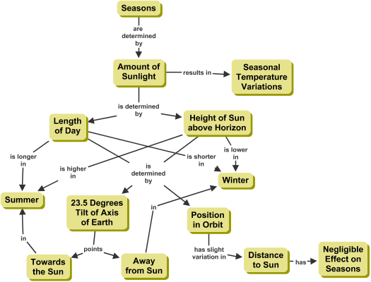
Figure 1. Concept map about "What causes Seasons"?
Building Propositions
Within a proposition, the linking words express the relationship that exists between the joined concepts in the specific context being considered. The following is a list of propositions from different topics:
Birds have Hollow Bones
Energy is the capacity to do Work
Learning can take place through Apprenticeship
Credibility is the basis for Good Journalism
Successful Businesses create Wealth
Increase in Rainfall may cause Flooding
Notice that in each of these propositions can be read independently and understood, even though the context of the proposition is not clearly stated. For this reason, they are sometimes called semantic units, or units of meaning. Each of these propositions consist of two concepts connected through linking words (shown in italics) (e.g. the first proposition includes concept "Birds" and "Hollow Bones" and the linking word "have").
The following is a list of badly formed propositions, since they don't convey any meaning:
House of Cards
Birds in Trees
Fruit for example Apple
Education with Meaningful Learning
Exercise for Health
What does "Birds in Trees" tell us? Not much. What was the meaning that was meant to be conveyed with this proposition, maybe that "Birds live in Trees"? or that "Birds build Nests in Trees?" Adding a verb (live, build) changes the proposition into a unit of meaning, into a proposition that makes sense on its own and conveys knowledge. The other entries in this list also lack good linking words that better describe the relationship between the corresponding concepts.
Static and Dynamic Propositions
Linking words can express static and dynamic relationships. Static relationships between concepts help to describe, define, and organize knowledge for a given domain, while dynamic relationships describes how the change in one concept affects the other concept. Static relationships lead to static propositions, while dynamic relationships lead to dynamic propositions. In general, adequate knowledge representation requires both static and dynamic propositions, as it is the latter that capture covariation and changing relationships among two or more concepts (Derbentseva, Safayeni, & Cañas 2004). The following table shows sample static and dynamic propositions.
 | Static Propositions | Dynamic Propositions
 | Plants have Leaves  The Soldier fought like a Lion  Squares are Polygons  Energy obeys Conservation Laws | Increase in Rainfall may cause Flooding  Academic Performance in High School is a good predictor of Academic Performance in University  Travel Time is an inverse function of Speed for aGiven Distance
Concept maps tend to include mainly static propositions, leading to descriptive maps that don't provide much explanation. When establishing the relationship between concepts, we should make an attempt to describe not only static relationships, but also construct dynamic propositions that result in richer concept maps.
Propositions are not limited to connecting only two concepts. In the above list, "Travel Time is an inverse function of Speed for a Given Distance" included three concepts, "Travel Time", "Speed", and "Given Distance". However, when constructing concept maps we strive to keep propositions as short as possible, preferably connecting only two concepts.
References
Derbentseva, N., Safayeni, F., & Cañas, A. J. (2004). Experiments on the Effect of Map Structure and Concept Quantification during Concept Map Construction. In A. J. Cañas, J. D. Novak & F. M. González (Eds.), Concept Maps: Theory, Methodology, Technology, Proceedings of the First International Conference on Concept Mapping. Pamplona, Spain: Universidad Pública de Navarra.
Last update: June. 28, 2009

